实验七 CSS方框模型和定位

【实验目的】
- 掌握HTML和 CSS方框模型和定位。
- 掌握主要编程工具Notepad++、sublime。
- 掌握主要浏览器Firefox、Chrome

【实验学时】
建议2学时

【实验环境配置】
- firefox浏览器环境
- Notepad++、Sublime
- Windows 环境

【实验原理】
HTML和CSS方框模型和定位

【实验步骤】
- CSS边距和填充练习：
试着在firefox浏览器实现下图的效果：
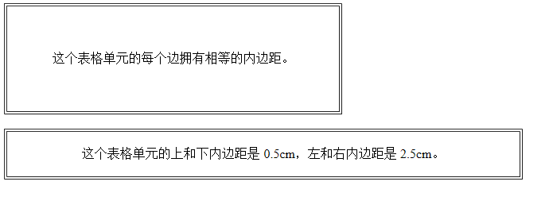

- CSS对齐练习。使用margin属性中心对齐,块元素可以把左，右页边距设置为"自动"对齐。margin属性可任意拆分为左，右页边距设置自动指定，结果都是出现居中元素：margin-left:auto， margin-right:auto，width:70%;
试着在firefox浏览器实现下图的效果。
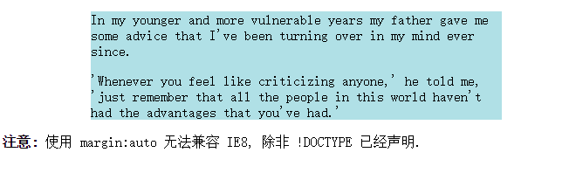
- 使用position属性设置左，右对齐。元素对齐的方法之一是使用绝对定位：position:absolute，right:0px，width:300px;。
试着在firefox浏览器实现下图的效果
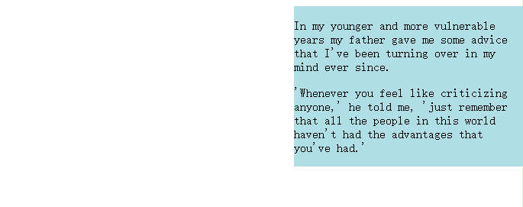

- 在CSS中，使用float属性设置左，右对齐。使用float属性是对齐元素的方法之一： float:right;
试着在firefox浏览器实现下图的效果:
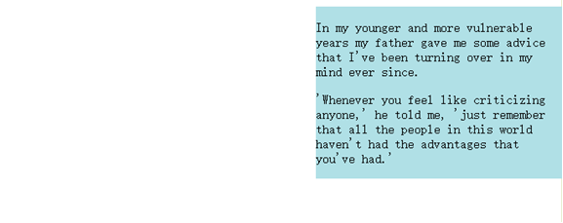

- CSS实现，彼此相邻的浮动元素。如果你把几个浮动的元素放到一起，如果有空间的话，它们将彼此相邻。
对图片廊使用 float 属性。试着在firefox浏览器实现下图的效果：
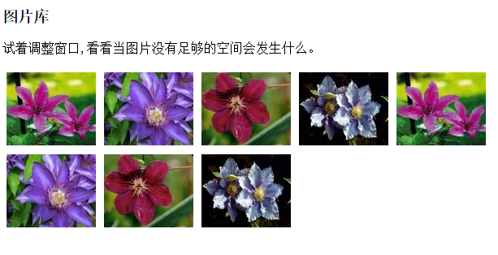

- CSS实现，清除浮动，使用 clear。元素浮动之后，周围的元素会重新排列，为了避免这种情况，使用 clear 属性。clear 属性指定元素两侧不能出现浮动元素。
使用 clear 属性往文本中添加图片廊，试着在firefox浏览器实现下图的效果：
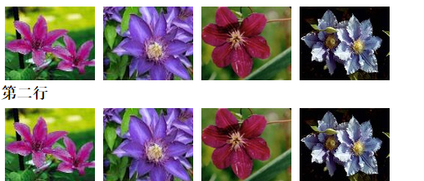
- CSS实现，Fixed 定位，元素的位置相对于浏览器窗口是固定位置。即使窗口是滚动的它也不会移动：position:fixed;
使用position的fixed，试着在firefox浏览器实现下图的效果，窗体滚动，右侧文字保持不动：
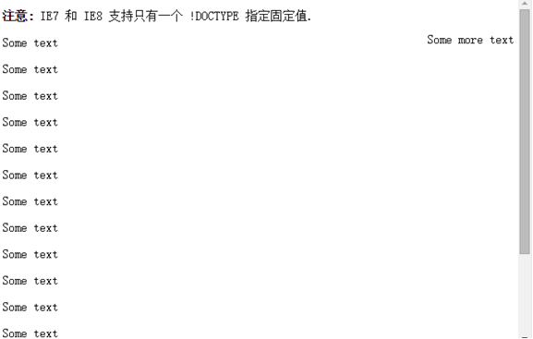

- CSS实现，使用滚动条来显示元素内溢出的内容。overflow属性创建一个滚动条，当一个元素的内容在指定的区域过大时设置自动适应。试着在firefox浏览器实现下图的效果：
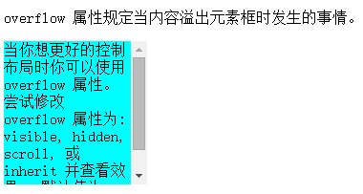

【结果显示】
第一题：
<!DOCTYPE html>
<html lang="en">
<head>
<meta charset="UTF-8">
<title>Title</title>
</head>
<body>
<table border="1">
<tr >
<th style="padding: 20px">这个表格单元的每个边拥有相等的内边距</th>
</tr>
</table>
<table border="1">
<tr>
<td style="padding: 0.5cm 2.5cm;">这个表格单元的上和下边距是0.5cm,左和右内边距是2.5cm</td>
</tr>
</table>
</body>
</html>
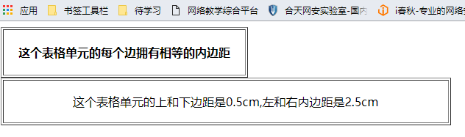

第二题:
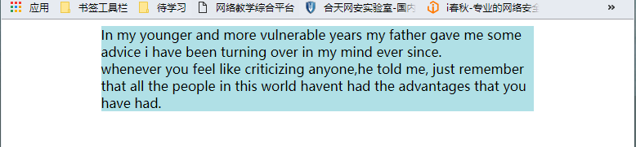
<!DOCTYPE html>
<html lang="en">
<head>
<meta charset="UTF-8">
<title>Title</title>
</head>
<body>
<div style="width: 70%; margin: 0 auto; background: #B0E0E6">
In my younger and more vulnerable years my father gave me some advice i have been turning over in my mind ever since.
<br>
whenever you feel like criticizing anyone,he told me, just remember that all the people in this world havent had the advantages that you have had.
</div>
</body>
</html>

第三题:
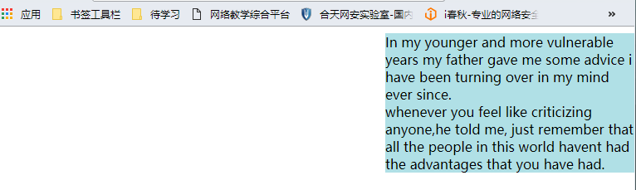
<!DOCTYPE html>
<html lang="en">
<head>
<meta charset="UTF-8">
<title>Title</title>
</head>
<body>
<div style=" margin: 0 auto; position:absolute;right:0;width:300px;background: #B0E0E6">
In my younger and more vulnerable years my father gave me some advice i have been turning over in my mind ever since.
<br>
whenever you feel like criticizing anyone,he told me, just remember that all the people in this world havent had the advantages that you have had.
</div>
</body>
</html>

第四题:
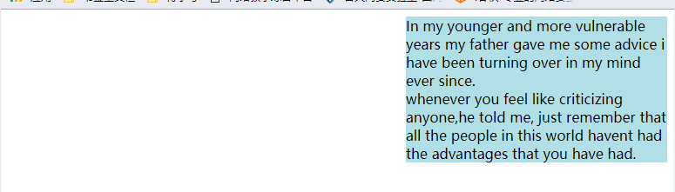
<!DOCTYPE html>
<html lang="en">
<head>
<meta charset="UTF-8">
<title>Title</title>
</head>
<body>
<div style="float:right;width:300px;background: #B0E0E6">
In my younger and more vulnerable years my father gave me some advice i have been turning over in my mind ever since.
<br>
whenever you feel like criticizing anyone,he told me, just remember that all the people in this world havent had the advantages that you have had.
</div>
</body>
</html>

第五题:
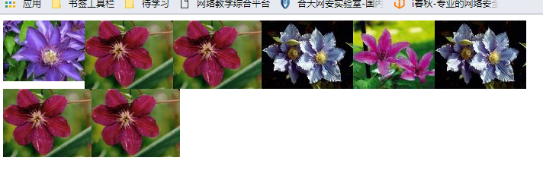
<!DOCTYPE html>
<html lang="en">
<head>
<meta charset="UTF-8">
<title>Title</title>
<style>
div img{
float: left;
}
</style>
</head>
<body>
<div>
<img src="klematis2_small.jpg" alt="">
<img src="klematis3_small.jpg" alt="">
<img src="klematis3_small.jpg" alt="">
<img src="klematis4_small.jpg" alt="">
<img src="klematis_small.jpg" alt="">
<img src="klematis4_small.jpg" alt="">
<img src="klematis3_small.jpg" alt="">
<img src="klematis3_small.jpg" alt="">
</div>
</body>
</html>
第六题:
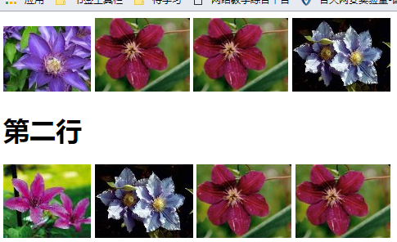
<!DOCTYPE html>
<html lang="en">
<head>
<meta charset="UTF-8">
<title>Title</title>
</head>
<body>
<div>
<img src="klematis2_small.jpg" alt="">
<img src="klematis3_small.jpg" alt="">
<img src="klematis3_small.jpg" alt="">
<img src="klematis4_small.jpg" alt="">
<h1 style="clear: both">第二行</h1>
<img src="klematis_small.jpg" alt="">
<img src="klematis4_small.jpg" alt="">
<img src="klematis3_small.jpg" alt="">
<img src="klematis3_small.jpg" alt="">
</div>
</body>
</html>

第七题:
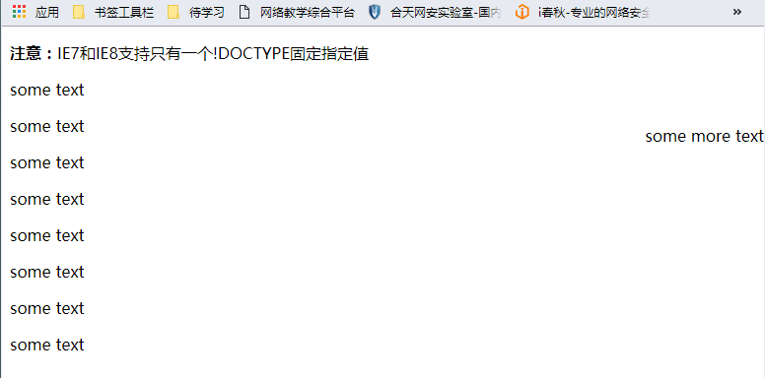
<!DOCTYPE html>
<html lang="en">
<head>
<meta charset="UTF-8">
<title>Title</title>
</head>
<body>
<p><strong>注意：</strong>IE7和IE8支持只有一个!DOCTYPE固定指定值</p>
<p>some text</p>
<p>some text</p>
<p>some text</p>
<p>some text</p>
<p>some text</p>
<p>some text</p>
<p>some text</p>
<p>some text</p>
<span style="position: fixed;top: 100px;right: 0">some more text</span>
</body>
</html>

第八题:

<!DOCTYPE html>
<html lang="en">
<head>
<meta charset="UTF-8">
<title>Title</title>
</head>
<body>
<div style="width:300px;height:200px;background: #B0E0E6;overflow: scroll">
<div style="height:300px;">In my younge
r and more vulnerable years my father gave me some advice
i have been turning over in my mind ever since
i have been turning over in my mind ever since
i have been turning over in my mind ever sincei have been turning over in my mind ever since
.</div>
</div>
</body>
</html>

